721 FEEDBACK

Text and Pictures elucidating Process oriented Feedback, Supervision, and the Learning Process

Amy Mindell
November 2005

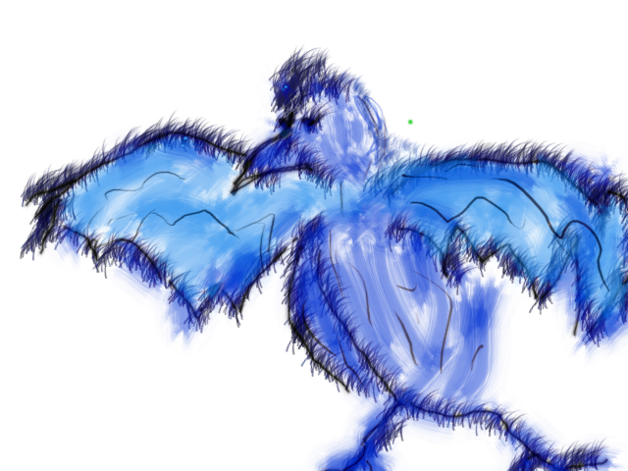

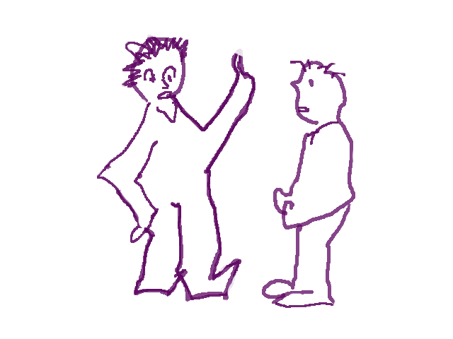

Consensus Reality

Dreamland

Essence

All of us are, or will one day be, in the position of giving feedback to others whether we are teachers, bosses, parents, or simply friends giving advice to one another. Over the years I have developed into a teacher and supervisor of other therapists and therapists-in-training and have found that, for me, the task of giving feedback carries as much excitement and learning as it is daunting and challenging. There is always more to learn about how to teach and give feedback in useful ways.

Supervision can be a wonderful learning process for everyone involved. At the same time, I am acutely aware that no matter how good hearted the supervisor might be, or how open and capable the supervisee may be, the atmosphere around a feedback situation is most often filled with various background spirits, some stemming from past wonderful or difficult educational experiences, earlier parental situations, abuse issues, etc. At the same time, the nature of the particular student or supervisee and the particular supervisor or teacher, the momentary mood, the “performance” that is being looked at, the moment in time, and the feelings of all involved play significant roles in what occurs. The person in the position of getting feedback may feel relaxed and excited about feedback or possibly uptight about what might be said. At the same time, the supervisor might feel fully engaged and interested or alternately, nervous about what to say, how to say it, or how to be conscious of the rank differences between her or himself and the supervisee.

Sometimes as a supervisor, I have had a sense of wellness and at other times I have felt quite ill at ease in my role. I have at times felt stuck in a traditional model of teaching that did not feel quite comfortable or suited to me. I have always attempted to give helpful information to my supervisees based on the person’s individual qualities, abilities, and style, yet I have often felt that the interaction was lacking something important, some deeper dimension that I was not touching upon. Questions filled my head. What is it that I, as a supervisor, can really give to others? Why is it that I sometimes feel that I am under scrutiny and supervision as well? Why do I often feel that I am not using all of me to engage in the learning and teaching process? What does it really mean to follow the feedback process rather than preconceived ideas about teaching and learning?

I reviewed some of the best learning experiences that I had had in my life. They all seemed to contain a sprinkle of something magical, mysterious or spontaneous, in addition to the practical material I was learning. I realized that this mixture of clarity and “magic”, everyday life and the dreaming process, was the key factor in my original interest in process work and in my desire to become a process-oriented therapist. However, I was not quite finding the same magic in my supervision work.

The Hidden Background to Teaching and Learning
I was greatly relieved when Arny began to develop a new form of supervision in 2002, which he called 721 Feedback. His concept of 721 Feedback is a refreshing and more encompassing approach to teaching and supervision than I had previously known and has since enhanced my supervision with others in magical ways. This new concept expands traditional feedback methods toward a more multi-leveled approach that incorporates the awareness of various dimensions of experience that arise during the supervisor-supervisee interaction. With the use of 721 Feedback, supervision broadens to include not only practical learning, but also the hidden dreaming background to teaching and supervision, which is crucial to any learning situation.

In this article I introduce the reader to 721 Feedback. The information you will find here is derived from Arny’s teachings and my recent classes in Portland on this subject, as well as our use of 721 Feedback with therapists in various countries around the world. The positive response to, and usefulness of this modality has pointed toward the potential cross-cultural application of these ideas.

I hope that the ideas in these pages will help to augment and enrich any methods that you already use for feedback and evaluation. For simplicity, in the following pages I speak about the process of 721 Feedback in terms of the interaction between a supervisor and a therapist-in-training though this model applies equally to other realms of feedback as well such as the interaction between instructor and learner, teacher and student, coach and client, boss and employee, etc. Your particular style will dictate how you might incorporate the following ideas into your own work. Some will use these ideas in a mainly cognitive way while others will use them in a more nonlinear way. In any case, any good supervisor already has elements of these ideas integrated into her or his work though they may not be identified as such.

360 Degree Feedback
The roots of 721 Feedback can be found in “360 Degree Feedback”, a term coined in the 1980s for an assessment and evaluation method utilized in some businesses and organizations for conveying feedback to a particular worker about her or his performance. We are very thankful to Dr. Max Schuepbach for originally informing us about 360 degree feedback in organizations. 360 Degree Feedback was designed as a more effective approach to feedback than the earlier “top down” style of evaluation (in which those above, such as the bosses, give evaluation to those below, i.e. the employees). “360 degrees” refers to all of the degrees of a compass and therefore, feedback comes from many sources and levels relative to the employee such as the employee’s colleagues (peers), supervisors, those workers with lower rank, customers (if applicable), and one’s own self evaluation.

360 Degree Feedback is certainly a milestone in the direction of shifting traditional styles of evaluation in organizations towards a less hierarchical and more holistic model. It places more “emphasis on empowerment, teamwork, continuous learning, individual development, and self responsibility.”

721 Feedback and the Deep Democracy of Education

A number of years ago, Arny broadened the concept of 360 Degree Feedback. In the context of supervision for therapists, but equally applicable to any educational or evaluative system, he began to speak about his concept of “721 Feedback”. He realized that while 360 Degree Feedback was an important step in relativizing rank differences and creating a more satisfying and well-rounded evaluation system, it can at the same time omit significant aspects of a person’s abilities and learning process. He pointed out that the content of 360 Degree Feedback mainly addressed the consensual performance of the individual according to agreed or consented upon measures. He noted that, while consensual measures are crucial, there are also other realms of experience that are fundamental to the learning process and the feedback interaction.

Arny based 721 on his concept of Deep Democracy, a philosophy and method that has been applied to working with individuals and groups. The concept of deep democracy refers to the equal importance of all people, parts, and levels or dimensions of experience whether in ourselves as individuals or in the groups that we are part of. The three levels are Consensus Reality, and the dreaming dimensions called Dreamland and the Essence.

Arny showed that, during teaching and supervision, a more in depth learning experience occurred when all of these levels were addressed. He came up with the term “721 Feedback” by designating 360 degrees to Consensus Reality (similar to the 360 Degree model), then he added 360 degrees for the level of Dreamland and 1 degree for the level of the Essence; hence the concept of “721”. All of the levels are important, of equal value, and are central to the process of teaching and learning. 721 Feedback requires that the person giving feedback notices the way in which each level arises during supervision, gains access to these various dimensions, and addresses them usefully in the supervisory interaction.

721 Feedback is an awareness-based method and therefore is dependent upon the supervisor’s ability to notice and address the various levels as they arise. Though I strive to focus on all aspects of 721 when I am giving feedback, I am not always successful; much depends on my momentary awareness. In addition, each unique situation between supervisor and supervisee may call forward, or highlight, one particular aspect of supervision over another.

However, if feedback is not focused on all of these levels at some point, most people have the feeling that something is missing; some piece of them feels misunderstood or simply unseen. Therefore, to really connect as a teacher or supervisor or friend with someone, feedback that touches upon all dimensions is crucial.

Brief Overview of the Three Dimensions
Let’s take a brief look at these three dimensions as they apply to supervision. Later, I will elaborate further about each realm and will speak about how to use them in practice.

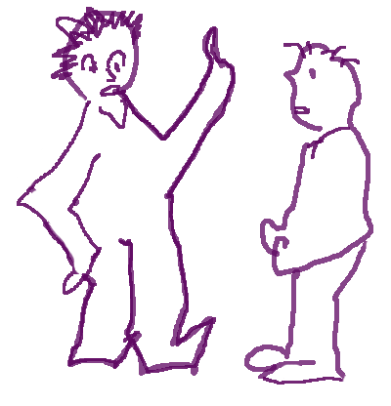
Consensus Reality (CR) correlates directly to the type of information conveyed in 360 Feedback. In CR, feedback focuses on the therapist’s abilities in terms of skills and metaskills deemed important in a given therapeutic community. Feedback can come from supervisors, peers, clients, and the therapist’s own feedback to her or himself. Evaluation and learning parameters depend upon the particular therapeutic school, specific task, or organization. In process work some important skills include the ability to notice the structure of the client’s process, communication edges, signals, channels, and the use of such feeling skills (what I call, “metaskills”) as compassion and fluidity.

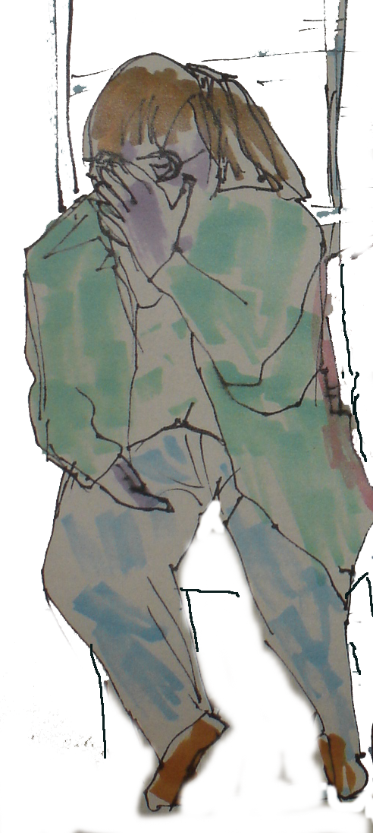
Dreamland takes us to another realm that may seem a bit unusual for those of us who are used to focusing solely upon the level of consensus reality. However, it is not hard to imagine the dreamland background to supervision. All of us are subtly aware of other dreamlike feelings and figures that arise during any given feedback interaction.
For example, imagine that a supervisor begins to give feedback to the supervisee. Before the supervisor says anything, the supervisee’s shoulders rise up, her head sinks down, and she begins to look afraid. Even if the supervisor is full of positive feedback, there is most likely another figure, such as a negative critic, in the atmosphere who is unsatisfied with the therapist’s work. This “critic” will inevitably voice her or his opinion internally to the supervisee, during and most likely after the supervision session, regardless of what the outer supervisor says.

Such figures can silently and powerfully dominate the feedback interaction to such an extent that they can potentially obviate any other learning. Imagine that, as the supervision session progresses, the supervisee’s face slowly becomes glazed over. She may nod her head at what the supervisor is saying but does not really hear anything -- except the critic’s incessant voice, that is! The critic’s opinions are like a semi transparent cloud that overlays and colors the momentary situation.

Interference in communication by one figure or another is more common than not. In fact, because of the complex nature of supervision and feedback it is rare in such situations that only the supervisor and supervisee are present in the room! All sorts of figures may be in the atmosphere such as a nasty demon, a loving and supportive elder, a playful child, a depressed person, or even a jealous colleague! Even if they are not directly focused upon, these figures will subtly influence and disturb both of the individuals involved.

You might ask why it is important to notice these dreamland figures in such learning situations. Dreamlike moods and figures have a powerful influence and are, therefore, crucial aspects of the learning process. They can enhance, disturb, or cloud the momentary situation for all. An astute supervisor will notice dream figures that are present and bring them into the feedback process. He or she will know that the moment of learning and feedback is a complex mixture of all of the parties, moods, and figures involved and that when focused upon usefully, in addition to consensual elements of feedback, the overall learning process will be enriched. I will give some examples below, but let us first take a peak at the realm of the Essence.


The Essence level takes us to yet another dimension of feedback. In general, the essence refers to the deepest part of us: an aspect of ourselves that encompasses and embraces all of our parts. Arny calls this part of each of us, “the Big U”. In embodied form, it is something like a wise elder inside of us that includes, yet is greater than the sum of, all of our parts. The Big U has a compassionate attitude that embraces all the various aspects of ourselves and a sense of detachment that comes from being connected with something greater than the momentary events of life; a sense of eternity outside of ordinary time and space. A playful image of the elder is the octopus (left), which is deep in the sea, has arms to embrace all the various sides, yet is more than the sum of all of them. In order to get close to our essence as supervisors, we need the capacity to slip a bit into an altered state and to feel the deepest part of ourselves. There are many methods to do this and I will mention some of them a bit later.

In supervision, using the Essence means that the supervisor gets in contact with the deepest part of her or himself and lets feedback flow from this aspect of her nature to the supervisee. In fact, the supervisor’s Big U is her or his best teacher. When she looks through the eyes of this deep part of herself she can speak to the depths of the supervisee as well.

The supervisor can speak from this Essence level in a given moment or the feeling quality of the Essence can be used as a basic metaskill from which all feedback occurs (including that of CR and Dreamland). In recent seminars, we have seen that feedback at all levels is best conveyed and also received when it emerges from the Big U of the supervisor. When the supervisor comes from her own deepest essence, the act of supervision transforms well beyond the typical realms of the “good” or “bad” abilities of the supervisee. Rather, whatever feedback occurs is embedded in a larger context that embraces the momentary learning as well as the wholeness and depth of the learner.
You may be wondering if it is then possible to give negative feedback to the supervisee. Actually, the Big U makes such feedback easier and more effective. The Big U makes it possible for the supervisor to feel freer about all the various aspects of her feedback because they will be conveyed through the feeling quality of her or his Big U attitude. For example, Arny has said that when negative feedback such as “I think you are not doing well at a particular skill” comes from a Big U feeling, it is communicated with a sense of detachment and therefore does not carry the normal sting that such information usually carries. The most painful feedback often occurs when the supervisor is not feeling detached but is intensely invested in what she is saying. And of course all of us have that from time to time! That is natural, too, and I have been through this many times! However, if complex or difficult feedback is said with the metaskill of detachment, the supervisee will get the message that she or he should learn something but that she/he is a creative and deep individual nonetheless with her or his own path and process.

Deep democracy emphasizes the equal importance of all three levels. They are like parallel worlds occurring simultaneously though we often tend to focus only on one and disregard the others. This marginalization of particular levels is natural, but to really connect as a teacher or supervisor, feedback at all dimensions is needed. However, exactly how and when a supervisor will use these levels depends on her or his particular style and the momentary feedback situation.

Local and Nonlocal Supervision: Learning Together
Arny has described the difference between “local” and “nonlocal” supervision. Consensus reality is local, meaning that you are you, and I am I. We are separate individuals. However, in Dreamland and in the Essence worlds events are nonlocal; that is, in dreamland dream figures and experiences are shared and do not belong to any one individual. He calls this phenomenon Non-Consensus Reality (NCR).

Most of us are familiar with the local style of supervision or education. The teacher is the teacher. The student is the student. In nonlocal supervision, the roles are not set or fixed but are shared by all. In nonlocal supervision, feedback that I give to you also applies to me in some way. We are both teachers and learners simultaneously. Both viewpoints, local and nonlocal, are important in the feedback process.

Here is an example of nonlocal supervision that some may be aware of. Imagine that a supervisor tells a supervisee a number of times that she or he should learn a particular thing. In consensus reality the teacher is teaching something and the student is trying to learn it. Let’s say, that with consistent reminders and discussions, the supervisee does not seem to learn or pick up the new information no matter how many times he or she is told to do so. The supervisor becomes frustrated and has an affect and insists that the student learn that particular thing!

In such a situation, if the supervisor cannot get out of her affect, then it is time to consider that the learning problem is shared. While it may be very true that the supervisee needs to learn something, at the same time the supervisor should consider that she herself might need that learning as well! If a supervisor insists repeatedly, for example, that a student-therapist be more direct and less mothering with her clients, the supervisor probably has the same difficulty with her own clients.


Here is another example of nonlocal supervision. In one of my supervision sessions, I noticed a critic in the air who was plaguing a supervisee. However, I also realized that I was feeling quite inhibited myself and that this critic was bothering me as well! We both agreed that there was a nasty spirit in the air. I decided to place one of the many puppets I have in my office, a green demon with a nasty scowl on its face, on the ground to represent the role of the critic. Both the supervisee and I took turns moving the critic’s head and speaking its words and criticizing our work. As we played with this figure, we broke out into laughter. We realized that both of us had been feeling shy with one another and that the critic showed us that we needed more of its intense energy. The supervisee needed to be more direct with her clients and I needed to be more direct about my feedback!

Simply sharing and admitting that you, the supervisor, have similar difficulties and problems as the supervisee can be very helpful, alleviate some of the rank differences between you, and create more learning for all.

2/3 of the Teacher is Inside, 1/3 Outside

The idea that the teacher and student are shared roles is quite important. While an outside supervisor or teacher is obviously crucial for learning, it is helpful to remember that each individual’s best teacher is her or his own process. No outer teacher will ever be as good as, or as helpful as, a person’s own inner process. The person’s inner teacher is, and will always be, the best guide in all things. In essence, Arny has said that 2/3 of the teacher is inside the student and 1/3 of the teacher comes from the outer teacher. The individual’s inner teacher (her or his own Big U) knows things that no one else can teach her or him. A supervisor who is aware of this will enlist the supervisee’s inner teacher as a guide and helper. Perhaps the supervisee can step out and supervise herself at one point or another in order to help bring this inner wisdom to the fore.

Recognizing Dreamland Figures

The exact information that each supervisor conveys in Consensus Reality is dependent upon the particular therapeutic paradigm that he or she is working in, and the individual nature and focus of a given supervisor. Therefore, I will not go into greater detail about CR feedback. I would however like to expand upon methods for gaining access to the Dreamland and Essence worlds and a few ways to use that awareness usefully in the supervision interaction.

Stepping into the realm of dreamland is one of my favorite activities! It gives me a chance to drop out of my “ordinary” mind and allow other information and figures to arise. For some this is a natural process while for others it is quite a stretch to momentarily drop consensual thoughts and notice a dream figure in the moment.

Therefore, a diversity of methods that match the supervisor’s style and nature are needed. Some discover dream figures by listening exactly to the content of what a person says, others use a kind of shamanic altered state to imagine figures, and still others observe a person’s body signals for clues. In any case, it takes a slight shift in awareness to open up to and notice the “other” figures that are in the midst of a supervision session.

The basic idea is that something about the figure’s energy or essence or the interaction with this figure is important to the person’s learning process. For example, it is possible that the person realizes that he needs to stand up to a negative critic and defend his way of doing things. Or, he or she might need to integrate some of the critic’s (or another figure’s) energy or essence. (The essence means the very root or seed of a figure, not just its overt manifestation. For example, the root of a critical voice might be “exactness” or “one-pointedness”.)

There is no prescription for exactly what you should do with a dreamland experience; each supervisor will have her/his own style depending upon the momentary situation and the supervisee’s process. A general method, however, might include first noticing a dreamland figure, bringing it into the conversation, and waiting for positive feedback from your supervisee about that figure’s presence. Once you have that response, you can go further and explore this figure in any creative way that feels right for you and the supervisee. You can think about the figure and what it might mean for the supervisee’s learning. You can dialogue with this figure and even get up and play it out in order to get to know it better. The process then will tell you what direction is important. I will intersperse a few examples below.
Let me outline four methods for discovering dreamland figures. Let’s call them “ghosts” referring to figures that are “in the air” but not yet directly represented in the interaction.

Notice Ghosts That Are Implied In What The Person Says
If you listen carefully to the content of what a supervisee says during the feedback interaction, you can often discover ghosts in what is implied in the person’s statements.

For example, imagine that you are about to give feedback to a supervisee and she or he says, “I feel shy about my work, did I do it wrong?” In this case, the implied figure is some critical character that is saying that the person did something incorrectly.

References to third parties (who are not present) are also indications of ghosts in the air. Imagine someone saying, “Oh gosh, my colleague “so and so” would have done that so much better than me.” In this case, the “colleague” is a third party, a ghost that can be brought into the feedback session. This “other” person will surely have something interesting to say!

Notice Ghosts in the Person’s Behavior and Body Signals
You can also notice ghosts by watching a person’s behavior and body signals. For example, imagine that at the moment that feedback is about to begin, the supervisee sits up very straight and clutches his jaw as if ready to go to battle. What ghost might be present? Perhaps it is a soldier who is ready and determined to meet any challenge!

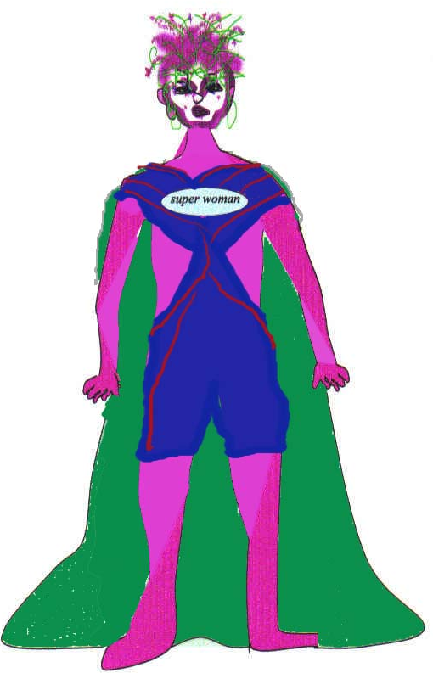
As mentioned earlier, if the supervisee’s head sinks down into her shoulders and she has a slight look of fear or anticipation on her face, there is most likely some critic or critical parental figure in the air.

If you are not sure what figure lies in the supervisee’s signals you can simply ask what she or he is experiencing. For example, imagine a woman who sat up straight, raised her chin slightly, and had slight smile on her face as our supervision began. When I asked her what these signals were expressing, she said that she felt a sense of pride in her work. In fact, she felt like superwoman!

Letting Yourself Dream About Figures In The Atmosphere

Another helpful method for discovering ghosts, particularly for those who do not focus on signals and content but who are more accustomed to, or enjoy, altered and shamanic states is to shift into a slight foggy state of consciousness and imagine dream figures in the atmosphere. This is one of my favorite methods.
For example, in one of my supervision sessions, I suddenly imagined a monkey sitting on the back of my supervisee! I was really shy to say this but the supervisee was eager to hear my nutty imagination. When I told her, she said that she had dreamed repeatedly of a monkey as a child. This monkey was capable of being playful and taking it easy. When I asked her to imagine bringing more of these “monkey” qualities into her work and her learning she was delighted and felt that a heavy weight of seriousness lifted.

In another session, I imagined a jolly green giant in the atmosphere who wanted to voice his opinion of support for the therapist’s work! You never know what might arise!

If your imagination is not correct, let the person correct you or wait for another image to arise.

Noticing Dreamland Figures From Your Own Feelings And Behavior
Another method for discovering ghosts is to become aware of your own feelings and behavior and how those feelings indicate other figures that are in the ethers of the learning atmosphere.
For example, I recall a supervision session in which the supervisee said that he needed to learn many things and wanted me to give him very direct feedback about his work. However, when the time came for me to comment about his work, I hesitated to say anything negative to him. As I studied my feelings, I realized that I felt protective and wanted to care for the supervisee. I decided to meta-communicate about my feelings (that is, talk about my experiences) to the supervisee. I said to him, “I know you want me to tell you my opinions about your learning very directly and I would like to do that, but is there something forbidding me from saying anything negative to you? Is a mothering or a protective spirit in the atmosphere that wants to keep off any potentially difficult information?”

The supervisees insisted that he wanted to hear what I was thinking but after I hesitated once again he insisted that he had had many difficult experiences in the last days, and though he felt he needed a “tough” learning situation in order to grow more fully, he actually felt very raw and could hardly take anymore. He said that this forcefulness had recently dominated his personal life and he recognized that he had become a bit pushier while working with his clients than he was comfortable with. He then realized that while he at times needed this “push” in order to concentrate more fully, he would feel better if he was a bit slower and more sentient in his daily life and in his work with his clients. The man was quite content with the supervision. However, after the session, I noticed that the sense of protectiveness remained in me even hours later. Therefore, I needed to consider how I, from time to time, also tend to push myself further than I am comfortable with.

In another instance, I felt a bit ill at ease, as I was about to begin giving some feedback to my supervisee. I went into a slight altered state and noticed that if I were free, I would want to pull on the person’s legs and arms! My supervisee was very open and I told her what I was experiencing. She asked me to literally pull slightly on her arm and see what would happen. I did this and suddenly had the feeling that I was pulling her out of a box that she needed freedom from. Immediately she said that she felt imprisoned by all of the shoulds concerning how she ought to work with her clients. The demands on her made her feel very uptight and unfree. We then had a fruitful discussion about how she could use the energy and essence of the figure imprisoning her in a more useful way; to be more exact in her work. At the same time, she experimented letting go of all demands about what to do and having an empty mind to guide her in her work. Paradoxically, letting go and having an empty mind gave her even greater access to her skills and abilities.

Asking the Person about Dream Figures in the Atmosphere
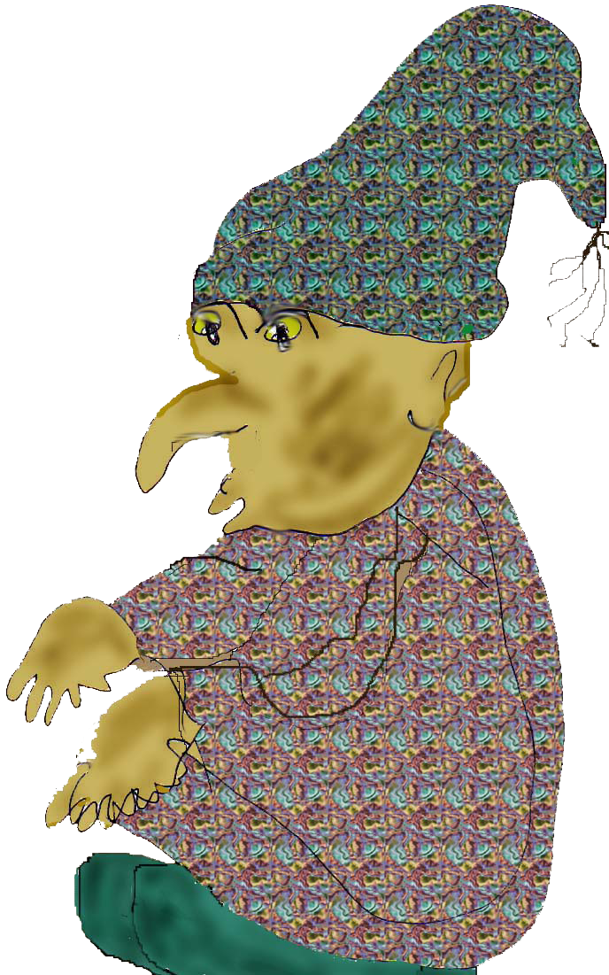
Finally, if your dreaming eyes are not functioning well on a particular day, or you are simply unsure of what figures are around, why not ask the supervisee what he or she imagines? He or she may have surprising and very helpful ideas about what dreamland figures presently inhabit the atmosphere!

A Short Exercise
In order to practice dreaming and noticing figures in the atmosphere why not try the following with a friend. Sit together and ask your friend to talk about his learning or anything else on his mind. Now, let yourself be in a slightly foggy, altered state of consciousness and hear, notice, or imagine some figure in the atmosphere, either from what your friend has said or done, from your own imagination, or from your own experience. Notice feedback and when your imagination receives positive feedback from your friend, simply discuss how this figure (or its essence) might be a significant aspect of your friend’s process and part of your own process as well.

Essence Feedback: A Basic Metaskill for all Dimensions

Giving feedback from the Essence level means that the supervisor connects with her deepest self and allows feedback to flow from this inner feeling about the supervisee. Sometimes I experience the Big U as if it were carrying me and showing me what to do and say to the other person.

The supervisor can give Essence feedback in a given moment or as the basis for all feedback that she conveys. As mentioned previously, all feedback including CR and Dreamland feedback, is best given and received when it comes from and is embedded in the supervisor’s Big U state. Therefore, it is helpful if the supervisor is able to get in touch with her Big U at the beginning of her or his supervision session.

There are many ways to get in contact with your deep essence. Here are a couple of methods:

Relax And Remember The State Of Sleep
Relax and imagine that you sink into the state of sleep. From this deep dreaming mind in yourself begin to speak and give feedback to your supervisee.

Put Yourself in the Service of a Greater Mind
Imagine putting yourself in the service of a greater mind such as the earth, the universe, the spirit, etc, depending upon what image and feeling is right for you. Let go of yourself, feel yourself being moved by this greater mind, and from this inner feeling begin to speak to the supervisee.

Discover the Big U in Your Body
Discover your Big U by asking yourself where the deepest part of you is located in your body. Take time to feel it there in that part of your body. When you are ready, still sensing this part of yourself, turn and find the direction on earth or in your room that this feeling is drawn towards or is most closely associated with. When you have found it, take a few steps there, feel the meaning of that direction, and make a gesture that captures the significance of that path. Now, ask yourself, what type of style this feeling, direction, and meaning are recommending for you as a supervisor or therapist. Imagine how you would act, how you would relate as a supervisor with that style and feeling. Make a quick sketch of this gesture and put a few words next to it to capture its meaning. If you can, take this paper with you to your supervision sessions to remind you of this deep part of yourself.

When I asked myself recently about the deepest part of me, I sensed it in my chest and the feeling went towards Kenya. As I walked in that direction, I recalled the shamanic ceremony that Arny and I had participated in there. The people were extremely loving and shamanic. As a supervisor I imagined being very open and warmhearted about what I would say and at the same time a bit unpredictable and dreamy, allowing my shamanic nature to express itself through the realms of Dreamland and the Essence.

Here are a few examples of giving feedback from the Essence
In one situation, after giving CR and Dreamland feedback to a supervisee, I sank further into my Big U and began to speak. I said that while the therapist-in-training was struggling to learn various things there was also something very earthy about him that would never be altered or destroyed and that would be his greatest gift in his work with others. The therapist felt that I had touched upon something that he cherished about himself but rarely focused on, and that he could use this earthy feeling more in conjunction with his skills.

In another situation, as I began to give feedback to a woman therapist from my Big U, I felt myself becoming very quiet and respectful. I felt there was something else I needed to say before I could speak about her skills. I realized that she had a certain presence of heart that, from my Big U perspective, needed to be honored and respected. The woman said that she had always been aware of a big loving presence inside of her. She meditated on this feeling for a moment and said that contact with this feeling reconnected her with her initial reason for becoming a therapist. She said she had lost contact with this side of herself and that remembering it now gave her a deeper reason for what she was doing and would support her overall growth and learning.

In addition to the therapist being close to her Big U, it is very helpful if the supervisee is able to be close to her Big U as well during the supervision interaction. From the supervisee’s Essence state of mind, she will hear the feedback perhaps in a new way (through the eyes and ears of her Big U), may feel more fluid with the feedback situation, and will also be able to give herself feedback from her deepest self.

A Few Tips For Doing 721 Feedback
The following is a basic 721 Feedback Exercise that you can practice with friends, supervisees, colleagues, etc. Before describing the exercise, let me mention a couple of helpful tips.

Follow The Momentary Process
Supervision is an interaction more than anything else. The supervisor says something, the supervisee responds in some way, the supervisor notices feedback, etc. The process has its own natural and organic method of unfolding that involves the consciousness of all parties, though the supervisor in this case ideally has more awareness and will use it to the benefit of the supervises.

Therefore, the following exercise is not meant as a strict linear process that must be followed step by step. For example, in Part II, you might skip to Dreamland feedback first due to a dream figure popping up strongly in the moment. Then you might flow to CR feedback, or to the Essence, etc. The whole process has to do with your ability to notice feedback, to interact with the supervisee/therapist, and to flow with the various levels as they arise. Ideally, the supervisor will address all levels but follow the momentary process to determine what actually occurs. Most importantly, please use this exercise to practice your fluidity as a supervisor.

State The Level You Are Speaking From
A rudimentary lesson for 721 Feedback is to notice and speak about the level you are addressing in any given moment. For example, if you are giving factual CR information that you are interested in the person learning, state that you are speaking for the moment on the level of Consensus Reality. If you drop into the Essence, state that as well. Make it clear that you are shifting to one of the levels and will return to the others in due time.

Everyone In Every Position Learns And Teaches
The principle of nonlocality tells us that everyone is a teacher and everyone is a learner. Therefore, one of the steps of the exercise asks the supervisor to consider how the information that he or she is recommending to the therapist are also true for him or herself as well. I also include one further step and request that everyone in the triad give feedback to one another. The therapist can give feedback to the supervisor, the client can give feedback to therapist, etc. In my classes, many people seemed to enjoy this roundtable style of learning.

More Notes about the Exercise


In the exercise one person will be the client, one is the therapist and one the supervisor for approximately 40 minutes. If you have time, switch and change roles two more times in order for everyone to have the chance to be in all positions. Please be aware that this is a supervision and training exercise. Therefore, the focus is placed mainly upon the process of 721 feedback and less strongly on the client’s individual process. As a result, I have limited the time designated to the work between the therapist and client. However please feel free to adapt the timing to your own needs.

721 Feedback Triad Exercise

I. Working Together and the Therapist’s Inner Supervisor (20 minutes)

Everyone in the triad takes a few minutes to get in touch with her or his Big U by using one of the methods mentioned above.

The therapist works with the client for 15 minutes on anything the client would like to focus on.

After 15 minutes the therapist should recall her or his Big U, feel it and become it a bit. Then, as this Big U inner teacher, the therapist should take a few minutes to give her or himself advice/feedback about her or his work with the client.

II. 721 Feedback (10 minutes)
- The Supervisor now recalls and re-feels her Big U. From this feeling, she or he should begin to give 721 Feedback to the therapist. (Please also encourage the therapist to be in her or his Big U at the same time if possible.) The supervisor should follow the process as best as possible as to when and which of the following levels to speak about:
  - CR: Discuss skills, metaskills, etc. What was good and what more could be learned?
  - Dreamland: Notice/use your imagination to sense a dream figure in the atmosphere in the moment. Wait until you have positive feedback from the therapist and then dialogue with or role play this figure, and discover how its energy or essence is useful in some way to the therapist’s learning.
  - Essence: Sink more fully into your Big U and let deeper feedback flow out of you about the therapist.

III. Reflection: (10 minutes)
- What was it like for you, the supervisor, to give 721 Feedback? How fluid did you feel with the three levels? Did you stay in your Big U? In what way is the feedback you gave the therapist true for you as well?
- What was it like for you, the therapist, to receive 721 Feedback? What was most helpful to you?
- If time, do further roundtable-style 721 feedback. That is, the therapist can give feedback to the supervisor, the client can give feedback to the therapist, etc.

A Multi-Dimensional Life

I hope that the above exercise and the information in this short paper have given you a beginning sense of 721 Feedback. The concept of 721 teaches us that the learning process has many levels, some of which are often unseen. However, for a complete and rich experience for all, it is important to bring the consensual as well as the dreaming layers into dialogue. They are all important, present, and influential in any learning situation.

The practice of 721 Feedback has freed me to use more parts of myself as a supervisor and teacher, and I believe, to be of greater help to others. I have the potential to be didactic and practical. I can use my dreaming nature to discover the dreaming background behind interactions. And I can use my deepest self in the service of others. As I engage in this whole process I am both teacher and learner, weaving the practical and magical elements of self-discovery and learning together. At the same time I know that this learning does not stop when I leave a supervision session but that all of these dimensions are present in my life as a whole. Noticing how I fluidly move between the various levels from moment to moment is central to my sense of a fulfilling and creative life.

I hope that this short paper inspires you to explore these dimensions of experience, to enrich the process of feedback, everyday life, and to update and re-create education together!

“360 Degree Feedback: The Powerful New Model for Employee Assessment and Performance Maintenance” by Mark R. Edwards and Ann J. Ewen, American Management Assoc., New York, 1996, p.25.
“The term 360° feedback comes from the analogy to a compass: A circle with 360 points of reference used to determine and monitor direction. 360° feedback provides performance data from multiple points of reference, not just one. Like a compass, it is a navigational tool that more accurately tell when one is on or off course. It can fill the gaps that invariably exist between how one sees himself and how others see him. Its' purpose is, first, to gain deeper insight into how individual, and others, see the performance and, second, to reinforce and accelerate the need for continuous development.” From: http://www.bnet.com/abstract.aspx?scid=1539&sortby=title&docid=72256
Edwards and Ewen, p.5.
See Arny’s Leader as Martial Artist, HarperCollins, New York, 1992, pp.5-6, 154-155.
See my book, Metaskills: The Spiritual Art of Therapy, Lao Tse Press, Portland, OR, 2001.
See his Dreaming While Awake, Hampton Roads, Charlottesville, 2000, pp. 200-206.
Arny’s speaks about parallel worlds in quantum physics; particularly Hugh Everett’s many worlds interpretation. See his Quantum Mind chapter 18 pp. 227-236 and my article “Amy’s Hyperspaces: Creativity, the Bird of Paradise, and the Doorway to Parallel Worlds” ”on this website at http://www.aamindell.net/research_frame.htm.
See his Dreaming While Awake, Hampton Roads, Charlottesville, 2000, p.47.
From our earlier research and from my classes on the interface between learning skills and personal style we have discovered that if a person is unable to learn something over time, this usually indicates that there is a gift behind the learning difficulty that is not yet recognized. Only when this gift is valued will it potentially allow the “blocked” learning to occur. See my Alternative to Therapy, Newport, Oregon: 2002, pp. 314 - 315 for more on this.
See Arny’s The Leader as Martial Artist p.36 and my Alternative to Therapy, Chapter 9, pp. 93-101 for more on ghosts.
See Arny’s upcoming book (to be published) Cosmic Path Walker: The Teachings of Don Juan, Richard Feynman and Lao Tse in Shamanism, Physics, and Community for more on “directional” awareness.

